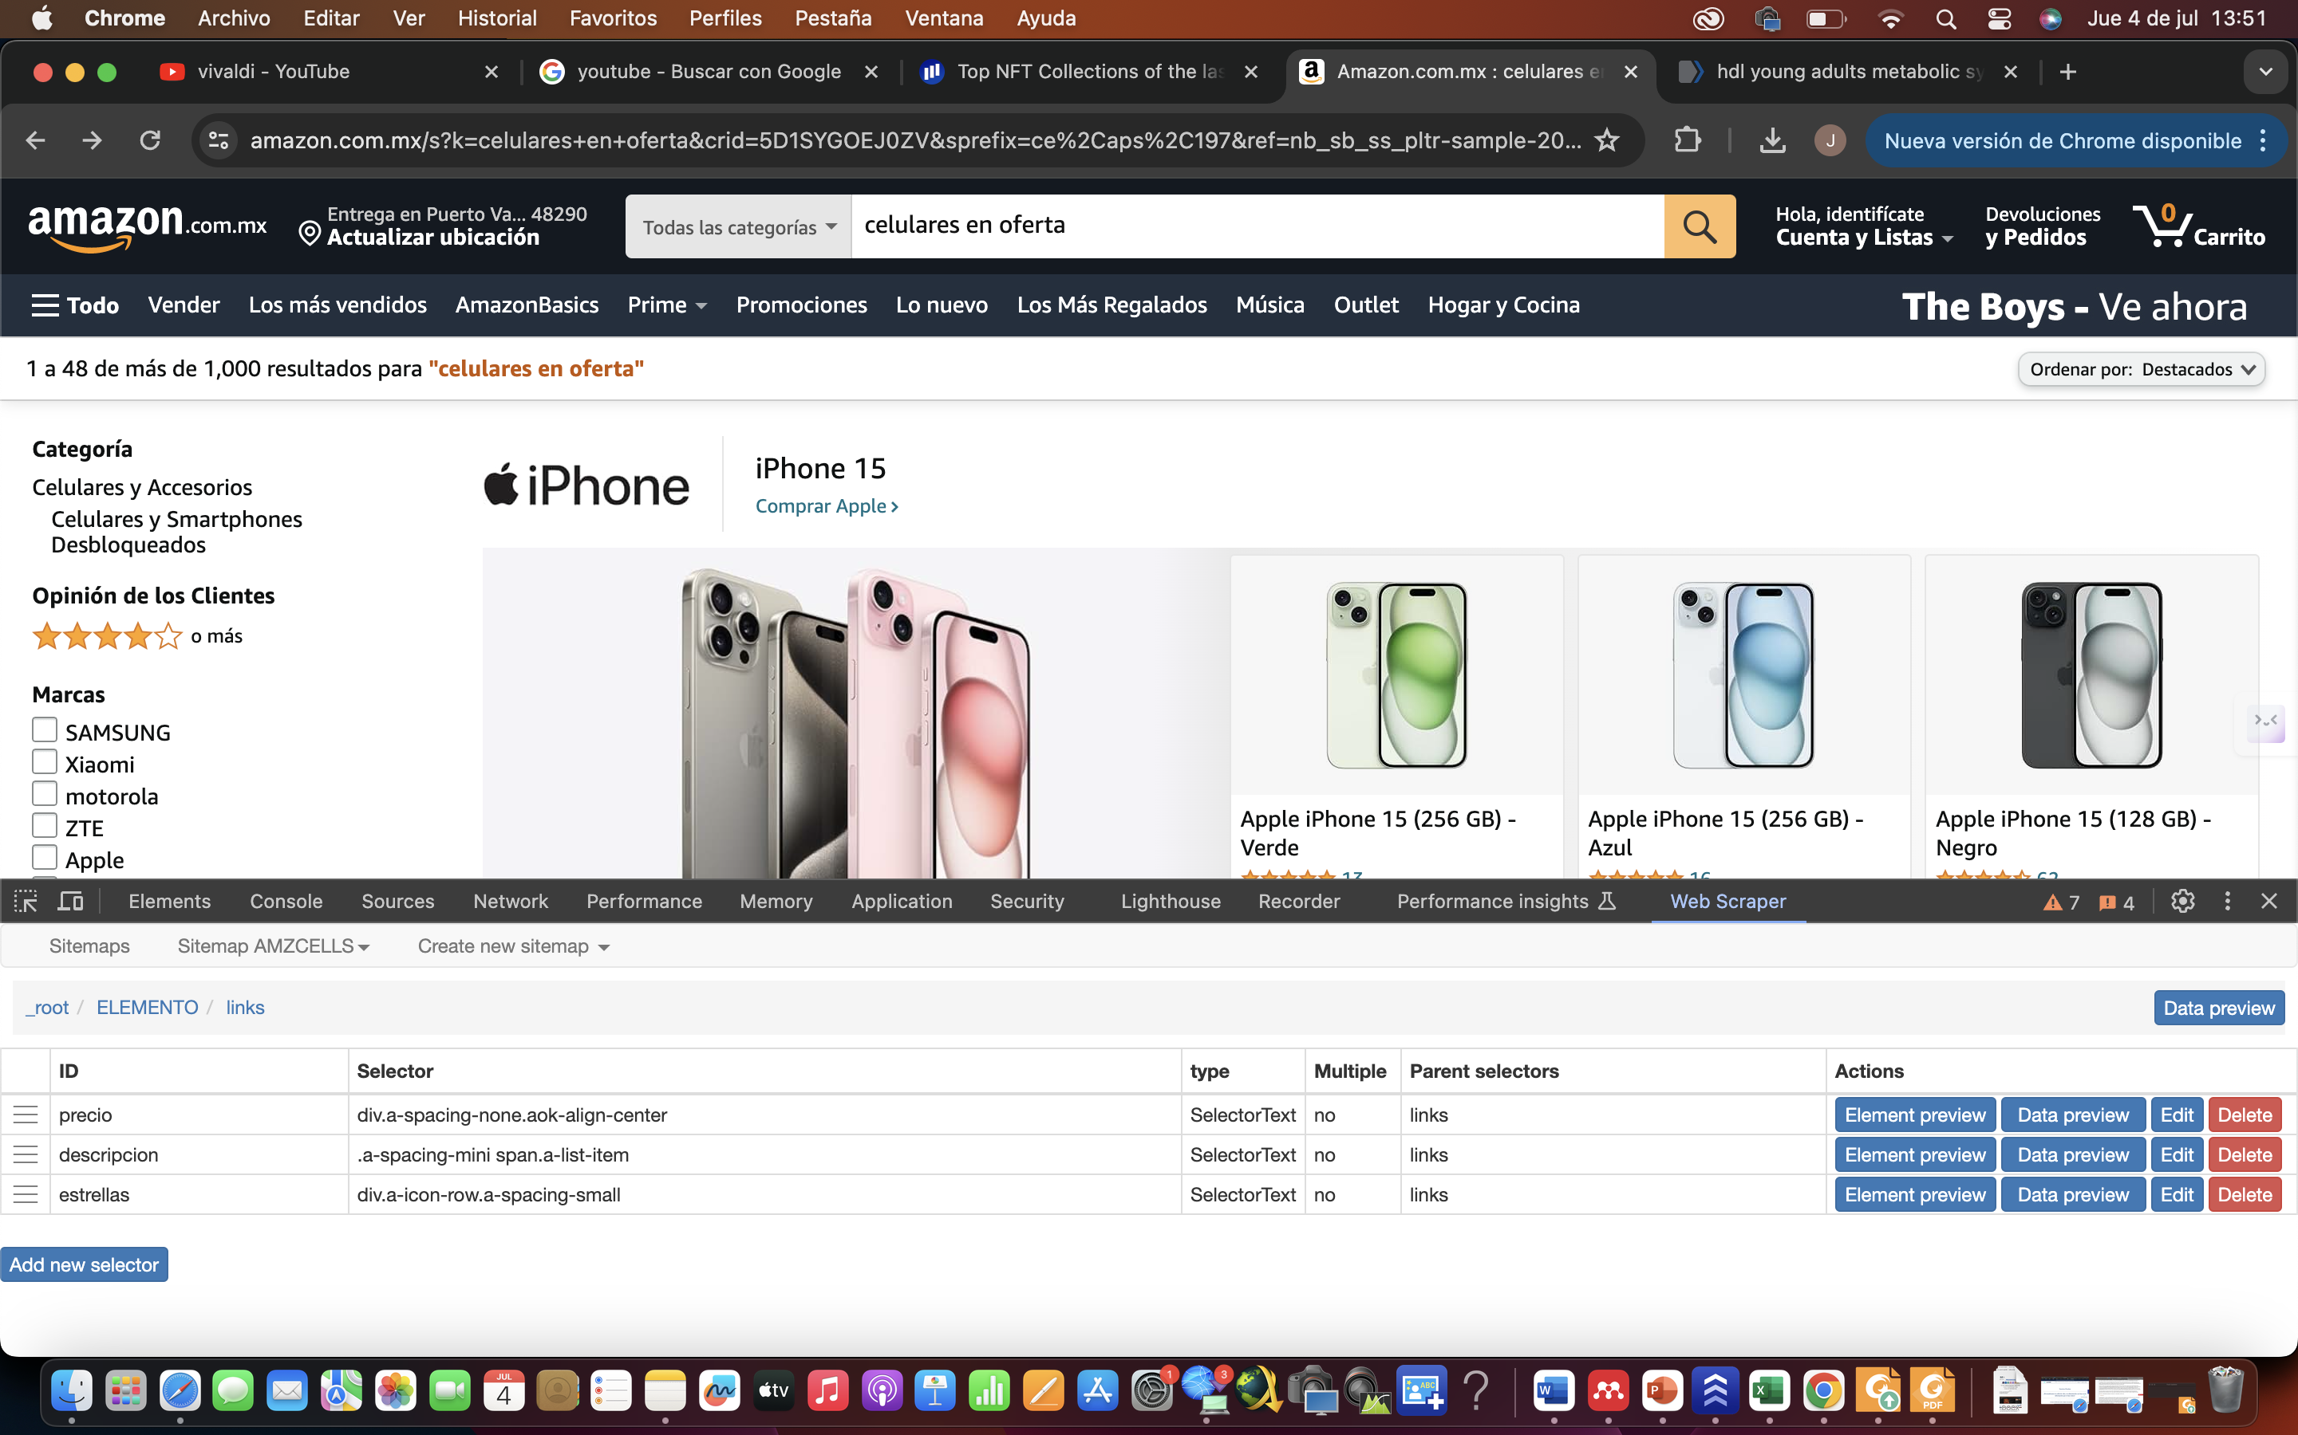

COMANDO:

{"_id":"AMZCELLS","startUrl":["https://www.amazon.com.mx/s?k=celulares+en+oferta&crid=5D1SYGOEJ0ZV&sprefix=ce%2Caps%2C197&ref=nb_sb_ss_pltr-sample-20_2_2"],"selectors":[{"id":"ELEMENTO","parentSelectors":["_root"],"type":"SelectorElementClick","clickActionType":"real","clickElementSelector":"span.s-pagination-item:nth-of-type(n+2), a.s-pagination-item","clickElementUniquenessType":"uniqueText","clickType":"clickOnce","delay":2000,"discardInitialElements":"do-not-discard","multiple":true,"selector":"div:nth-of-type(n+4) .s-widget-container > span div.a-spacing-base"},{"id":"links","parentSelectors":["ELEMENTO"],"type":"SelectorLink","selector":".a-size-mini a","multiple":false,"linkType":"linkFromHref"},{"id":"precio","parentSelectors":["links"],"type":"SelectorText","selector":"div.a-spacing-none.aok-align-center","multiple":false,"regex":""},{"id":"descripcion","parentSelectors":["links"],"type":"SelectorText","selector":".a-spacing-mini span.a-list-item","multiple":false,"regex":""},{"id":"estrellas","parentSelectors":["links"],"type":"SelectorText","selector":"div.a-icon-row.a-spacing-small","multiple":false,"regex":""}]}

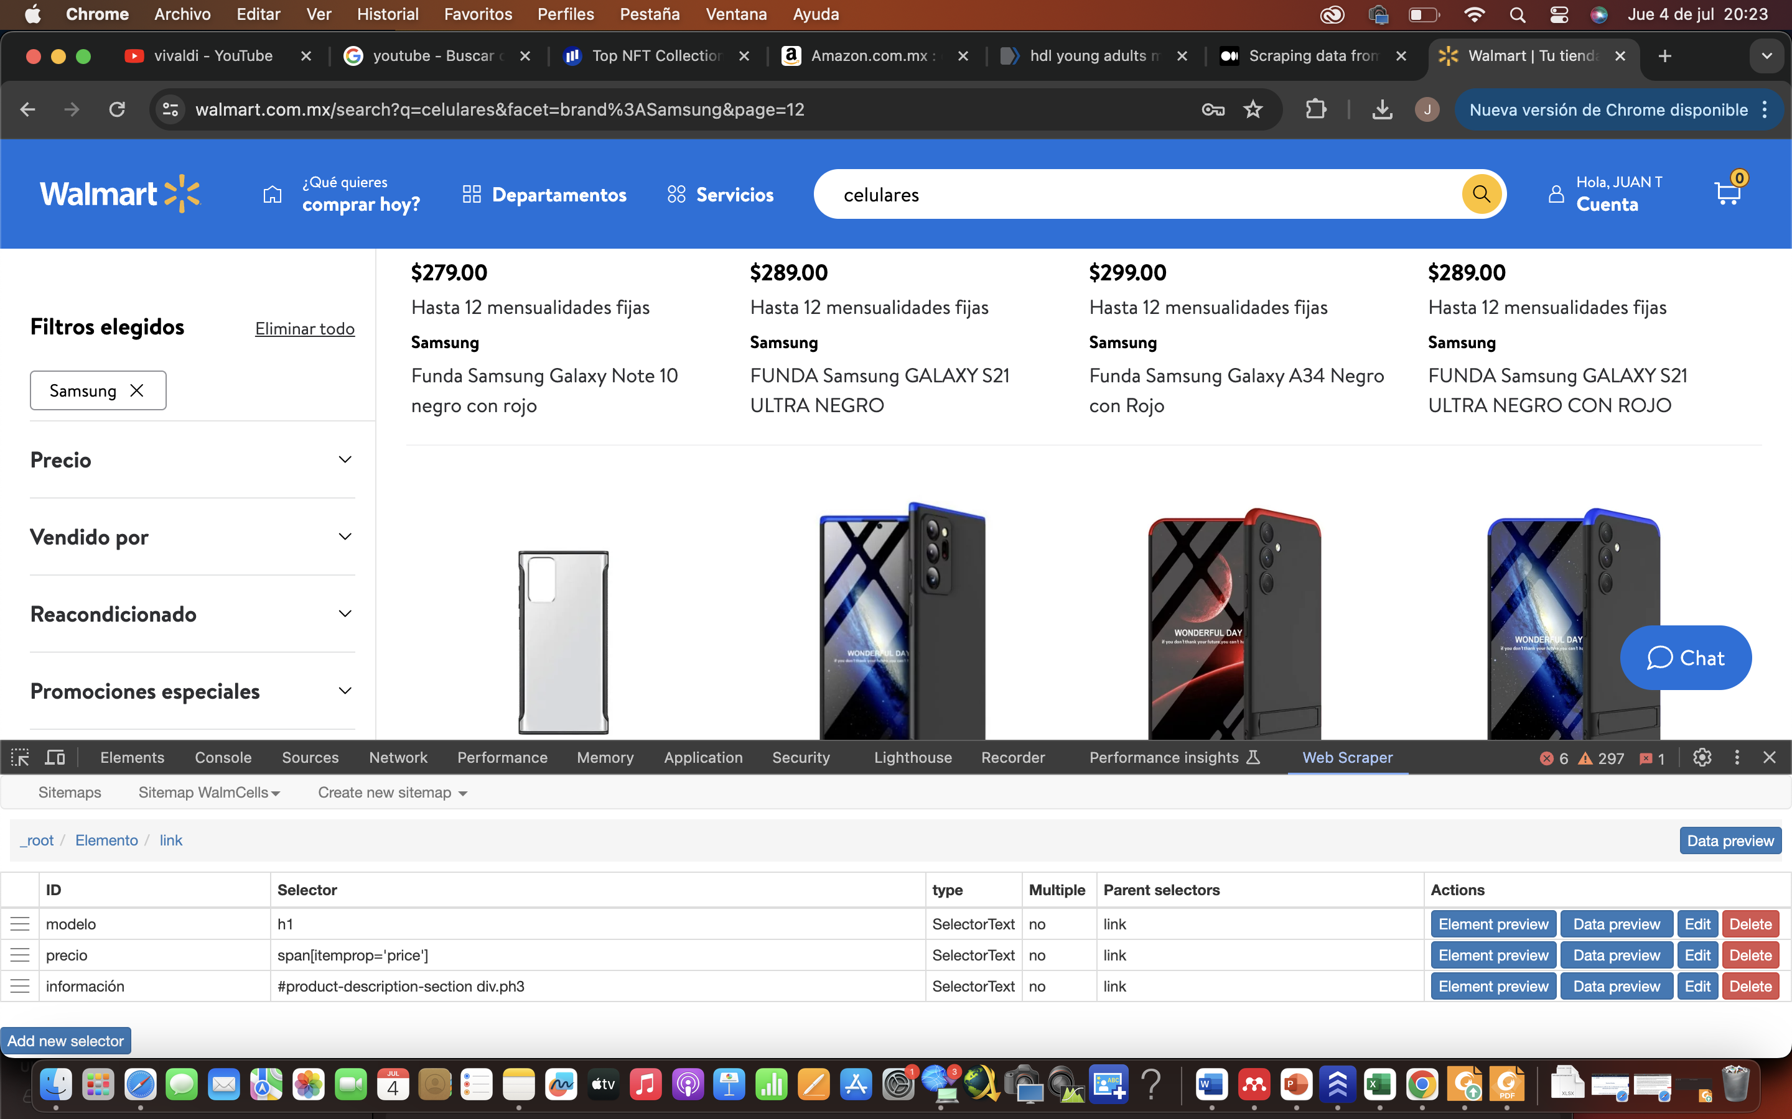

{"_id":"WalmCells","startUrl":["https://www.walmart.com.mx/search?q=celulares&facet=brand%3ASamsung"],"selectors":[{"id":"Elemento","parentSelectors":["_root"],"type":"SelectorElementClick","clickActionType":"real","clickElementSelector":"a.lh-copy","clickElementUniquenessType":"uniqueText","clickType":"clickOnce","delay":2000,"discardInitialElements":"do-not-discard","multiple":true,"selector":".bb a"},{"id":"link","parentSelectors":["Elemento"],"type":"SelectorLink","selector":"_parent_","multiple":false,"linkType":"linkFromHref"},{"id":"modelo","parentSelectors":["link"],"type":"SelectorText","selector":"h1","multiple":false,"regex":""},{"id":"precio","parentSelectors":["link"],"type":"SelectorText","selector":"span[itemprop='price']","multiple":false,"regex":""},{"id":"información","parentSelectors":["link"],"type":"SelectorText","selector":"#product-description-section div.ph3","multiple":false,"regex":""}]}